Foldable Instructions:

Using only one piece of paper, fold the paper in half so that the top half is a little bit shorter. On the front of the folded paper, draw a picture of an animal. Underneath the animal, write the name of the animal (this is why the top half is shorter!). On the inside, write the way the animal moves. Be sure to state whether the animal moves on the ground, in the sky, or in the water. Explain how it is able to do so by listing the appendages it has.

Here is an example:
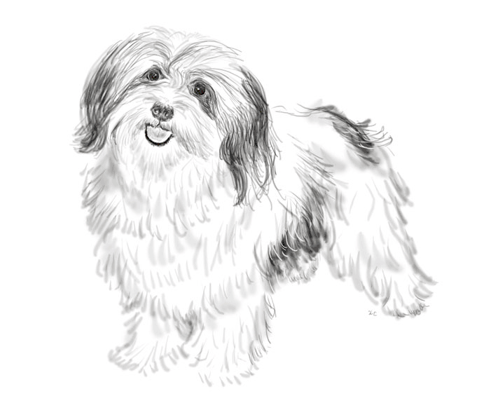
Outside
Dog

Inside
This is a dog. A dog walks on the ground. A dog is able to walk because it has four legs and four feet.

Dog

