Can we change the color of celery?

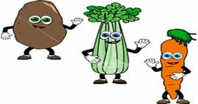
Team name: ____________________
Date: ____________________
Time: ____________________

1. What do you notice? Draw a picture:
Without a magnifying lens | With a magnifying lens
2. Make a prediction: Will the color of the celery change? Yes No

3. Why? _____________________________________
________________________________________________

4. What happened? Draw a picture:
5. Why did this happen? ________________________________________________
________________________________________________

