Directions:
You are going to be writing a letter to your favorite animal from the video that we just watched. In your letter, be sure to tell your animal that all of its basic needs will be met if it comes to visit you. Be sure to explain to your animal how you will obtain the resources!
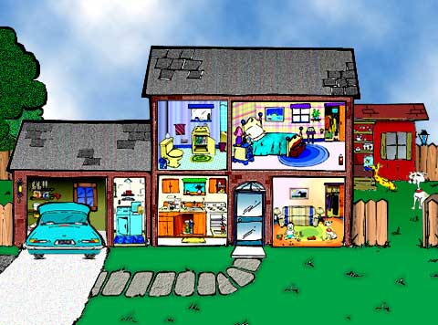
Dear Animal,
________________________________________________________________________________________________________________________________________________________________________________________________________________________________________________________________________________________________________________________________________________________________________________________________________________________________________________________________________________________________________________________________________________________________________________________________________________________________________________________________________________________________________________________________

