Directions: In your group, sort the plants that are on your table! Use the clues that are listed below each picture.

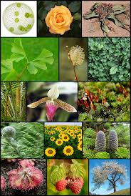

Once you have finished sorting the pictures, you are going to present your findings to the class! For your presentation, you are going to
- Say what category each plant falls into
- Say why you chose that category

Good Luck!

