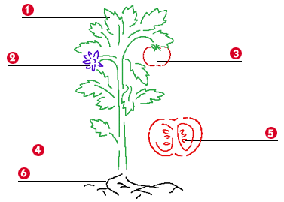

Can You label the parts of the plant?

1._________________ 4. _________________
2. _________________ 5. _________________
3. _________________ 6. _________________

