Time to make a collage!

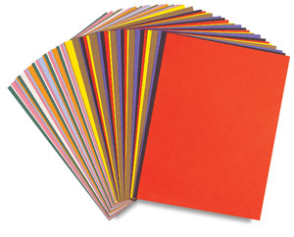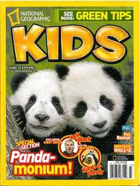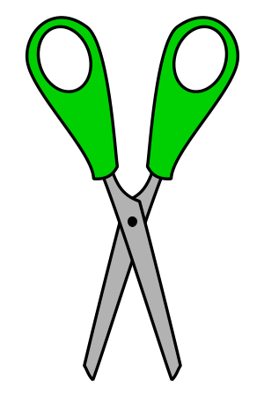

Using the magazines on your table, cut out the pictures of animals. Once you have cut out all of the animals that you want to be in your collage, paste them to a piece of construction paper (be sure to leave room to write on your paper!). After everything is glued down, identify the physical characteristics of the animals that you have chosen.

