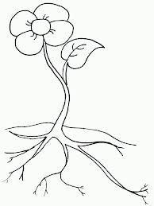
Cut Along the Horizontal (sideways) lines:
Fold Here:

For this Foldable, you are going to fold (towards the flower) and cut along the necessary lines. Once you have completed this part, you are going to write the name of the plant part on the outside of the blank paper flap, and write the plant part’s function on the inside. After you have labeled all of the plant parts and have described what they do, you may color in your flower!

